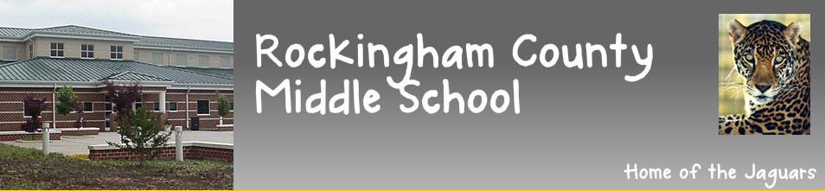

Dear Students and Parent(s)/Guardian(s):
In an effort to maintain the safety of our students, Rockingham County Middle School will require all students to have a signed permission form turned in by his/her parent for each athletic event that they plan to stay after-school for and attend. This is only for students that plan to stay after school for the event, and not for students that are planning to return to the event with a parent/guardian.

It is very important that all students and parents understand that the expectation for students that stay after-school for an athletic event, is for the student to attend the athletic event and support their RCMS athletic team. Students are not permitted to go off campus to Elizabeth’s during that time, go to the high school parking lot, or to go outside of the fan area. Once a student leaves the fan area, they will need to be under the supervision of an adult. Students that do not follow these rules and expectations, will not be permitted to stay after-school to attend future events.

Students will meet after school in the cafeteria, and will be escorted to the athletic field by a staff member. All student names will be checked off in the cafeteria, and verified that a permission form is located prior to being escorted to the event. Forms will be collected in the morning by Coach Saunders in the Main Lobby Area. All permission forms must be turned in by 12:00, the day of the event. Blank forms can be found in the main office and our school website. The cost of all athletic events is $3.00 at the gate.

Please complete the bottom portion of this form for your child(ren) to attend the desired Athletic Event. We look forward to a having your students attend our events in a safe and supervised area. Thank you for your help and support!

I give my child, ________________________________________________, permission to attend the _______________________________________(event) After-School Activity on __________________________________(date). I agree to collect my child promptly at the conclusion of the event at Rockingham County Middle School.
Parent/Guardian signature: ___________________________________________
Phone number (# that can be used in case of an emergency): ____________________

